PART 7: BUSINESS ARCHITECTURE CASE STUDIES

Introduction
The Business Architecture Guild is an international, not-for-profit, member-based professional association whose aim is to promote best practice and expand the knowledge base of the business architecture discipline. Its mission is to provide valuable business architecture resources and exclusive content to its members. Membership benefits include access to a private online community, a knowledge repository, newsletters, webinars, and opportunities to provide feedback and collaborate with the Guild on content for A Guide to the Business Architecture Body of Knowledge™ (the BIZBOK® Guide).
The Business Architecture Guild was established by a small group of industry experts in 2010 seeking to unify the discipline and the practice of business architecture. It now reflects a collaborative “brains trust” of practitioners and experts from around the world.
The Guild is registered in California as a not-for-profit corporation. It has seen its membership expand rapidly over its four-year lifespan, growing to around the 1,500 mark at the time of writing. Two-thirds of its membership resides outside of the United States, meaning that the organization has had to accommodate and be inclusive to an international audience from its inception.
It is governed by a Board of Directors, an Editorial Board (which focuses on the BIZBOK® publication), several administrative committees, and a variety of member-led teams responsible for developing BIZBOK® content.

The Current State
Like any organization (whether it knows that one exists and can describe it, or not), the Business Architecture Guild has a current-state business architecture. In the Guild’s case, that business architecture has not been documented anywhere before now. Part of the reason for that is the organization’s size and maturity: less value would have been gained from undertaking such an exercise in the early years when the enterprise was still evolving rapidly in both form and business direction. It is only within the past 12 months that the structure has stabilized to the extent that defining the business architecture makes practical sense and has become much more of a priority.
The size of the membership along with the range and complexity of the functions performed by different arms of the Guild has now reached the point where it has become necessary to capture (at a minimum) the current-state view of the enterprise. When there are so many people involved in a diverse range of activities across a variety of working groups, it becomes difficult for the executive leadership team to make informed decisions about how to continue to grow and move the Guild forward in line with its mission and vision. And unlike most private, commercial firms, the Business Architecture Guild’s modus operandi means that there are a lot of individuals becoming involved in the group’s activities, each of whom is likely to come with a different perspective on what the Guild does and how it makes those decisions.
The challenge was issued midway through 2014: to create a baseline business architecture for the Guild (following the principles and guidelines outlined in the BIZBOK® Guide), and to document the process and outcomes as a mini-case study in how to ‘do’ business architecture. The remainder of this chapter describes the approach the Business Architecture Mapping Team took to create the initial views, the various challenges encountered along the way (and how they were resolved), and what the outcomes (the maps) look like. As noted in ‘Next Steps’ below, the development of the Guild’s business architecture will be an ongoing, iterative process. This approach reflects the general principle that business architecture is not static but dynamic. Subsequent releases of the BIZBOK® Guide will include additional updates and insights as further mapping is completed.

Our Approach
The following points highlight and discuss the key steps that the Business Architecture Mapping Team took in developing the baseline business architecture for the Guild (as outlined in Section 3.1 of the BIZBOK® Guide: Common Approaches for Getting Started). As stated in the introduction to that section, there is not one right or wrong way to initiate business architecture. Every organization (and the Business Architecture Guild is no exception to this) has some unique aspect that will need to be addressed to successfully integrate business architecture into the organization. The unique aspects of the Guild relate to its non-traditional (in the sense of a commercial business) organizational structure; the evolving nature of the organization’s mission, capabilities and business activities; and its emphasis on collaboration as the primary vehicle for developing and delivering value to stakeholders. Individual organizations should therefore adjust how and when they employ each of the recommended steps based on their management goals, stakeholder expectations, and the culture of the enterprise.
The Business Architecture Mapping Team chose to apply the following five steps as part of the overall approach:
- Determine the business architecture objectives
- Communicate the business value
- Establish a business architecture governance structure
- Establish a business architecture baseline
- Refine business architecture governance and deployment
Future team activities (as explained in the Next Steps section) will address some of the remaining steps in the process, such as expanding the business architecture across other domains and leveraging the business architecture in initiative planning.

Determine the business architecture objectives
The objective for the Guild’s business architecture was expressed in the Introduction to this chapter:
To create a baseline business architecture for the Guild, following the principles and guidelines outlined in the BIZBOK® Guide.
In that sense, we were looking to establish a conceptual framework to help facilitate strategic planning, address executive priorities and deliver customer (membership) value, as opposed to using it as a way to address any specific tactical business requirement—at least not at that particular point in time.

Identify and communicate the value of developing a business architecture for the Guild
Given the objective, two primary benefits were expected to result from the work to create a baseline business architecture for the Business Architecture Guild:
- Provide the Guild’s leadership team (as well as the membership itself) with a structured, visual representation of the enterprise in order to provide a common framework for discussing shared business challenges and solutions, and to help teams make better, more informed decisions about how to support, manage, promote and grow the Guild’s business and business activities.
- By documenting the process along the way and presenting that as a case study on how to develop business architecture using a real-life example, members of the Guild and other interested readers will gain new insights and information to help them apply the knowledge contained in the BIZBOK® Guide in their own business architecture practice.
While it was deemed unnecessary to develop a full business case to support the initiative (as suggested in the BIZBOK® Guide), the value proposition still had to be vetted and approved by the primary stakeholders. The goals, objectives, scope, outcomes and benefits of developing a business architecture were incorporated into the team’s charter, and made available on the Guild website for review by all interested and affected parties.

Establish a governance structure
The Guild Business Architecture Mapping initiative involved a team of contributors from across the Guild’s membership community—people who possessed the required level of experience in the practice of business architecture along with a reasonable knowledge and understanding of the BIZBOK® Guide. The team was made up of representatives from a diverse range of organizations around the world, from specialist consultancy firms through to the business and enterprise architecture practices within major corporations.
The Business Architecture Mapping Team was organized under the auspices of the Collaborative Leadership Team structure and governance model as laid out on the Business Architecture Guild’s website (http://businessarchitectureguild.site-ym.com). Its charter details the purpose and scope of the group’s activities:
The Business Architecture Mapping Team was formed to draft, validate and publish a business architecture representing the Business Architecture Guild as an entity. The business architecture will include, as a minimum, the core (foundational) domains as depicted in Figure 1.1 of the BIZBOK® Guide: Capability Map, Value Map, Organization Map and Information Map.
The development of the Guild’s business architecture will also follow the practices set out in the BIZBOK® Guide.
The team’s activities are supported and governed by:
- A Team Leader;
- A Mentor, who ensures the business architecture adheres to the policies, standards and practices of the Guild and the BIZBOK® Guide, and provides a contact point back to the Editorial Board; and
- Various stakeholders who act as Subject Matter Experts over the course of the development of the business architecture.

Build a baseline business architecture
The actual work effort (to develop the business architecture) is the focus of the fourth and current step in the process.
There were various starting points that the team considered, including the capability map (which, as a general rule of thumb, serves as a useful foundation for the business architecture), the value map, the organization map or the information map. The BIZBOK® Guide sets out the pros and cons for each in Section 3.1: Common Approaches for Getting Started. The team elected to start with the organization map as this was one area that was relatively well understood and the details required to complete the map could be obtained quickly and easily.
With a draft of the organization map in hand, useful insights could be gleaned to help define the initial outline (Levels 1 and 2) of the capability map. That, in turn, led to the identification of value stages and value streams that made up the value map. Each of these three maps are discussed in further detail in the following sections.

Refine business architecture governance and deployment
TBD: How to manage additional changes going forward, such as providing version control over models and maps.

Business Architecture Baseline

Organization Map
The scope of organization mapping for the Business Architecture Guild extended beyond the enterprise’s internal business units and comprised the active committees, collaborative teams and third party domains as well.
The basic concept of the hub and spoke model was applied to represent the Business Architecture Guild from an organization mapping perspective. The hub represents a single centralized business unit, the nodes reflect business unit decomposition and the spokes are the communication routes between the nodes and the hub.
The following key principles served as a guide to our organization mapping effort:
- Organization maps provide visibility into the business.
- Organization maps require a focal point.
- Organization maps contain business units.
- A business unit may decompose into other business units.
- The organization map is constrained by the boundaries of the business.
- An organization map can include third parties.
The first step in creating the organization map was to determine the scope of the mapping efforts. The first iteration was to capture the current state of the Business Architecture Guild enterprise. The organization mapping team leveraged existing documentation, including the committee and team charters on the Business Architecture Guild website, to understand the organization structure, the purpose for each business unit, committee and collaborative team and their respective lead contact or chair person. If existing documentation was not available or gaps still remained, the organization mapping team worked with the subject matter experts within each of the respective functions to close the gaps. The Guild organization attribute information was captured in a spreadsheet, depicted in Figure A.
Figure A:
After the organization attribute information terms were was captured in the spreadsheet, the spreadsheet was imported into a modeling tool (the IRIS Business Architect was selected since it supports the Business Architecture Metamodel) in order to create the organization map, an example of which is depicted in Figure B.
Figure B:
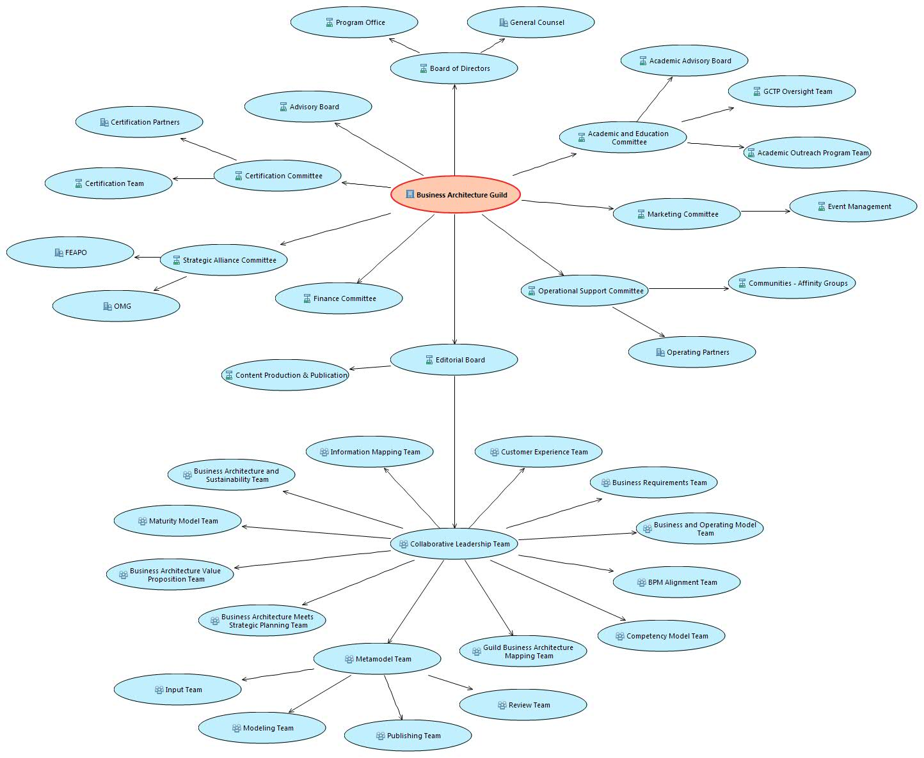
The most up-to-date versions of the organization map and other key artefacts can be viewed and downloaded from the Business Architecture Guild website:
https://businessarchitectureguild.site-ym.com/page/ORGChart2/?
The organization map was validated with the subject matter experts within each of the respective functions and changes were applied as appropriate.
In future iterations of the organization map, the relationships to other concepts, such as business capabilities and value flows, will be established.

Capability Map
The development of the capability map, like many other components of the business architecture, has been an iterative process.
When the team was first engaged to develop the capability map, most functions of the organization had not been documented or, if they had, were not readily accessible.
A first-pass capability map was developed using three primary sources:
- A draft organization map had been created using input from SMEs within the organization.
- A public website, and expanded access website for Guild members, was available for review.
- An approach to developing a capability map is described in the BIZBOK® Guide Section 2.2.
A first draft capability map was developed from these sources. The approach taken was to combine generic examples within the BIZBOK® Guide and previous examples compiled by the author, with specific reference to the website to describe the macro (Level 1) functions performed by the Business Architecture Guild. Note that emphasis was placed on describing what was done, not how it was done, in keeping with the definition of capability.
Usually the business architect will have some domain specialization, which will mean that some capabilities are more fully described than others in the first pass. In this particular example, the business architect had a publishing background, so the capabilities related to content publishing were initially described in more detail than other components. Where possible¸ the business architect should re-use their domain knowledge, as this will ensure the early versions capability map contain as little redundancy as possible.
Once a draft capability map was produced (see Figure C), this was provided to subject matter experts for review. When reviewing capabilities, subject matter expertise aligns with the capability levels; that is level 1 and 2 capabilities are best articulated and reviewed by C level executives, lower levels are typically detailed in keeping with the organization hierarchy.
Figure C:
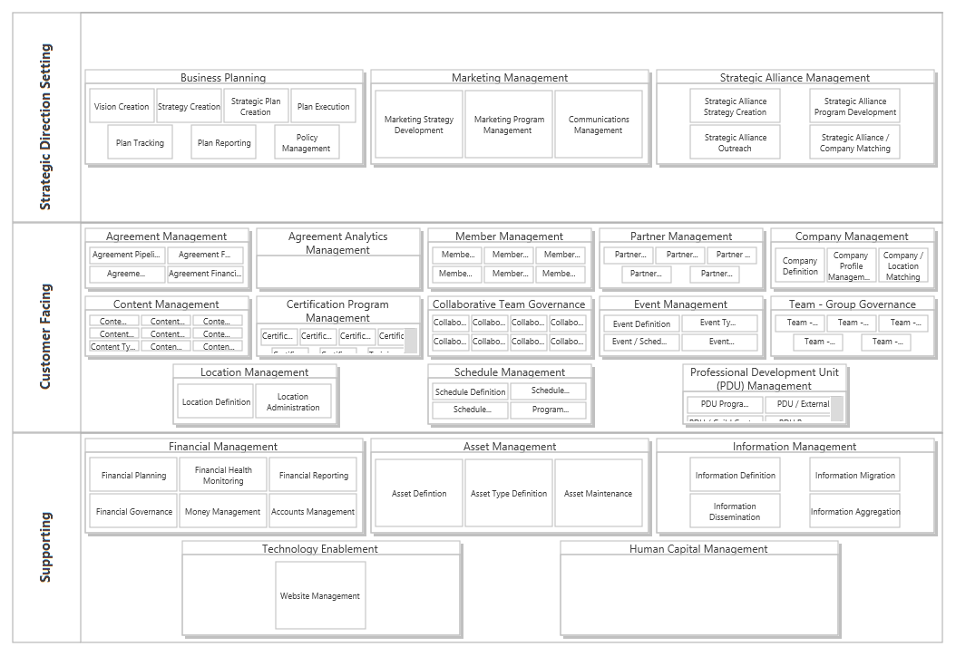
By taking this collaborative approach, the business architect forms relationships across all tiers of the organization and ensures completeness, accuracy and buy-in of the capability map and the naming conventions are readily understandable as they use language and acronyms known to that organization.
In the specific example of Business Architecture Guild, upon review with the subject matter experts, it became obvious that the Guild was a relationship-based organization. For that reason, the capability map emphasizes the relationships, both formal and informal between entities, locations and functions as being key to the success of the business.
Other points noted for further development that are relevant to any organization:
- The Business glossary was initially populated with the information terms gleaned from the organization map. Further population of the glossary will take place as information terms are uncovered from the Capability Mapping exercise (which covers the breadth of the organization and may highlight areas previously not addressed in the glossary).
- Completion of other Business Architecture artifacts will drive updates to the Capability Map. It is important to recognize that Capability Mapping is an interactive process and will change as more information is uncovered and as an organization changes.
- If the Capability Map contains words, terms or concepts that are not understood immediately by Subject Matter Experts, it must change. Then Capability Map must be complete, useful and relevant to the organization for which it has been developed, or it will rapidly fall into disuse.

Value Map
The approach taken to create a value map focused on value-stream analysis because of its end-to-end, member-focused perspective of how The Business Architecture Guild delivers value to its stakeholders.
The scope of the work encompassed all aspects of how The Business Architecture Guild delivers value to its stakeholders. The value streams focused on creating high-level value stages that contributed to an end-to-end perspective of how value is delivered to a specific group of stakeholders. Stakeholders included organization mapping entities as outlined in (section xx), with a particular focus on members and partners.
The following principles provided the guidelines to creating the value streams:
- Ensure each value stream has a clearly identified triggering stakeholder or set of stakeholders
- Focus on the customer/member or externally facing value streams as a priority
- Use the capability map to test and refine the value streams; use value streams to test and refine the capability map.
The initial list of value streams was produced by a business architect using the following artifacts and their knowledge of the Business Architecture Guild business operations:
- Business Architecture Guild Capability Map – used capabilities to map to value stages within a value stream. Made sure value streams captured key customer-enabling capabilities.
- Organization Map – used key information concepts to help define capabilities and capability descriptions, including the correct use of stakeholder terminology.
The initial value stream list was created in a spreadsheet (see Figure A) that included:
- The name and definition of each value stream
- The name and definition of each value stage within a value stream

Figure 1: Example Value Stream Map Draft
Once the initial value streams and stages were developed, they were validated and modified with a small group of executive stakeholders in a workshop setting. The high-level value streams were validated first, followed by the value stages within the value streams. Each executive member had access to the current Business Architecture Guild Capability Map and Organization Map that helped test and refine each value stream.
An important note when drafting value streams is to be consistent when using terminology and concepts between maps. Future development of the value streams should reference a consistent naming convention or glossary.

Key Insights
The following is a work-in-progress...
- Draft something before talking to the SMEs – use publically available information and reuse common concepts from business you understand already or that are common across industries (example Accounts Payable). By doing so you have a basis for discussion and get more useful insight faster, as typically your SMEs won’t have been involved in developing a Business Architecture before.
- Don’t force the organization to use your language. Use theirs. The Business Architecture must be understandable within the organisation, it is easier for you to change than to change the organisation.
- The development of each artefact is iterative, each one informs the other, so accept that changes are inevitable, but important to ensure consistency across the Architecture
- We had clearly defined roles from the beginning (e.g. Mentor versus SME versus Architects versus you as our Lead versus our Tool Support) AND we had people who were experienced in all of these roles. You all already knew how to architect. As SMEs we also knew how to architect, so hopefully we made your jobs a little bit easier. I think having tool support readily available and part of our team also helped with our productivity. I think clarity of roles and experience in them made this possible to do completely remotely as well, otherwise it could have been hard. I think the lesson to others is to make sure to have a good Mentor and at least an experienced architect who can mentor others involved (versus all new people trying to figure it out from each other).
- The fact that we all used the BIZBOK as a common framework made this go faster and removed all contention about how we were going map this or that (including some of the absolutely trivial discussions that we end up entertaining when we do this for organizations like arguments over syntax and such). We could just focus on getting the job done, not how.
- I think the prioritization and focus (e.g. which maps to do first) helped. I feel like we kept the activity pretty simple too.
- As I mentioned on the phone, I believe that the key now is this…so I think this is a recommendation to others and we ourselves need to act on it…
- Going forward the Guild needs to have an owner and advocate of the business architecture who will continue to socialize it with the various Guild boards (and the membership where applicable) and ensure that it is used. For example, when we have a board meeting where we are doing strategic planning, Bill and I need to bring out the architecture and use it for context. If we don’t continue to remind our peers about it and use it, it will sit on a shelf (but don’t worry about that!). We need to get it incorporated into the fabric of how we work.

Next Steps
Now that the mapping team has developed the majority of the core domains, their focus will turn to extending the business architecture with cross-mapping and delivering value from the business architecture. The team’s business architecture development has closely followed the third value stage of the Business Architecture Value Stream; as such the team will look to move to the fourth and fifth value stages.
As the team continues to evolve the business architecture, they will also incorporate improvements and clarifications using an iterative process managed by a business architecture governance structure (once it has been established). The team has developed a process for tracking and communicating changes to stakeholders, while the business architecture is being utilized As part of a good change management process, any changes to the business architecture will require verification across the other domains. For example, edits to an information concept will require a review of capability names that are cross-mapped to that information concept.

Additional Core Domain
The one core domain that was not mapped by the team was Information. Information mapping is covered in section 2.5, and was evolving as the team performed core domain work. While the information concepts were not fully defined at this point in the case study, the team has started that work by identifying the information concepts that underlie the capability map. This has generated a starter set of information concepts . This starter set will be further refined as the team examines the matching capabilities, identifies capability-information cross-mappings – including creation and consumption of information concepts, and reviews the starter set with Business Architecture Guild subject matter experts.

Relationship mapping
An additional set of work for the mapping team will be to identify the cross-mappings between the core domains. In order to do this, the team’s domain experts will need to work together, and with Business Architecture Guild subject matter experts, to determine where there are connections between capabilities, value streams, information and organization. This activity will give insight in to how each domain impacts the others.
The relationship mappings have many benefits, each of which are outlined in the specific section of the BIZBOK® Guide (sections 2.2-2.5). For the Business Architecture Guild, these cross-mappings will be the first documented insight in to the interactions of the domain concepts, which can be used to identify dependencies and other relationships in a rapidly expanding, distributed organization such as the Business Architecture Guild.

Managing an Iterative Process
As each cross-mapping is identified the team will need to examine the impact of any changes. For example, during the mapping exercise, a capability was identified as Business Planning. However, the information mapping sub-team was initially identified an information concept called Strategic Plan and Vision, which was interpreted by the team to be the outcome of this process. While this could conceptual be correct without much of a leap in understanding, the combined mapping team conferred on how to resolve both maps to ensure a common business vocabulary, ultimately ending in a renamed information concept called Business Plan. The alignment of naming allows for consistency across business architecture domains.
Similar efforts are expected as the four core domains are cross-mapped, resulting in a collaborative, iterative process that will solidify a common business vocabulary. An important finding of the team related to this collaboration is that it is imperative to communicate even minute changes to any business architecture perspective.

Future state view
One consideration of business architecture that needs to be reinforced throughout the mapping exercise is that the future state view (of the business architecture) should guide changes to the current state view (of the business architecture). There were elements within the Business Architecture Guild’s business architecture that are not yet fully instantiated, such as Marketing Program Management, Certification Program Management, and Schedule Management. The maturity of these capabilities and related perspectives will be further evaluated with heat mapping, as discussed in the “Leveraging the business architecture going forward” sub-section.
Similar efforts will be pursued as the four core domains are cross-mapped, resulting in a collaborative, iterative process that will solidify a common business vocabulary. An important finding of the team related to this collaboration is that it is imperative to communicate even minute changes to any business architecture perspective. The change highlighted in the previous paragraphs also impacts the value mapping team, which will need to ensure any usage of the former. This approach reinforces the dynamic nature of a business architecture. The mapping work was used to not only reflect but to consider and design ideal business structure, concepts, designs, and directions. This is a true benefit of the mapping exercise. As the Guild continues to evolve organically and strategically, the business architecture will mirror that evolution in both structure and content.

Leveraging the business architecture going forward
As a quickly growing organization, the core mappings are helpful to reflect and communication changes being made. As leadership is expanded and distributed, there is a common set of perspectives – especially capabilities – upon which activities can be founded and shared. This enables the Business Architecture Guild to quickly bring on new leaders, collaborative teams, and broaden the basis of members’ knowledge.
As the Business Architecture Guild moves forward, the leadership intends to utilize its business architecture for a variety of activities, including investment planning, improving member services, communication/onboarding, and strategy development. The common business vocabulary provided through the business architecture will allow the members, leadership, and board of the Business Architecture Guild to speak in common, consistent terms. In addition, through cross-mappings and heat mapping, shared focus can be placed on collaboration and organizational improvement.

Summary & Conclusion
TBD

Business Architecture Guild, A Guide to the Business Architecture Body of Knowledge™, v 4.1 (BIZBOK® Guide), 2014. Part 1, Page 8 and Appendix B.1, Page 446-447.

